What is on a pay stub?
Assignment: You will be learning how to read a pay stub. Here is an example of a pay stub and the explanation of what each section means. Each pay stub will look different but they will have the same information on it.
- Look over the following pay stub sample and the explanation of terms
- Answer the following questions

Explaining your pay stub
If this is your first job, you may not be familiar with all the information on pay stubs. Most pay stubs have certain parts in common. They may look like the example below.
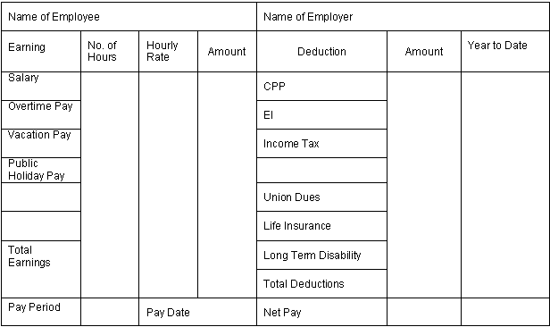

Explanation of Terms
Name of Employee | Your name
Name of Employer | Name of the company or organization you work for
Total Earnings | Kind of earnings; for example, salary, vacation and public holiday pay, bonus, commission, and overtime pay. When annual holiday (vacation) pay is paid on each paycheque, it must be shown on your pay stub. Please note that tips are not considered wages, as they are not paid by the employer.
Number of Hours | Number of hours you worked. On some pay statements, where time is broken into units or hours, this is called number of units or number of hours.
Hourly Rate | The amount of money you earned per hour
Amount | Total for that kind of earning (hourly rate X number of hours)
Deduction | Amounts taken off your cheque for different reasons. The most common deductions, which you will see on every paycheque: Canada Pension Plan or CPP, Employment Insurance or EI, and Income Tax. Other deductions often include: Union Dues, if you're a member of a union; Life Insurance, in the event that you die; Long-term Disability insurance, in the event that you are seriously injured or develop a long-term illness and can't work.
Year to Date | The total deductions in each category since the beginning of the year (optional)
Total Earnings | Your total earnings in the current pay period (gross pay)
Total Deductions | Total taken off your cheque this pay period and since the beginning of the year
Pay Period | The time you're being paid for on this pay statement; for example, Apr. 1 - Apr. 15
Payc Date | Date the cheque is issued
Net Pay | Your take-home pay after all deductions

When you start a job, keep track of the days and hours you work in a notebook or on the calendar. Check your pay stub to make sure it's accurate. Talk to your employer right away, if you have questions or concerns about your pay. Always keep your pay stubs in a file folder, shoebox or other storage container.
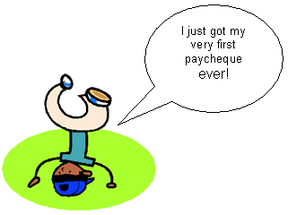

What is on a pay stub?

Michael's First Paycheque
Insturctions: Read the following pay check and answer the questions below.
Michael gets paid every two weeks and this is the pay stub from his first paycheque.
Name of Employee: Michael Jones |  |  |  | Name of Employer: Earl's Eating Emporium
Earning | No. of  Hours | Hourly  Rate | Amount | Deduction | Amount | Year to  Date
Salary | 30 | $10.00 | $300.00 | CPP | $12.91 | $12.91
Overtime Pay | 2 | $15.00 | $30.00 | EI | $9.68 | $9.68
Vacation Pay |  |  | $17.30 | Income Tax | $48.43 | $48.43
Total Earnings | $347.30 |  |  | Total Deductions | $71.02
Pay Period:  June 10 - June 24, 2012 |  | Pay Date:  June 29, 2012 |  | Net Pay: |  | $276.28

1. What is Michael's hourly rate of pay?

2. How many hours in total did Michael work during this pay period?

3. What is the pay period for this paycheque?

4. How many days from the end of the pay period does the employer have to pay Michael? Did the employer follow the Labour Standards rules?

5. Michael received $30.00 in overtime pay. Explain how Michael's overtime pay was calculated.

6. Why is the amount of EI (Employment Insurance) deducted on this paycheque the same as the amount in the "Year to Date" column?

7. How did the employer come up with the amount of $276.28 as Michael's net pay?

Extra Questions: Answer the following

- What is CPP? Explain what it is and why it is important.

- What is EI? Explain what it is and why it is important.

- What is a union?

